Women Safety App: Real-Time Edge AI SOS Detection via AMD XDNA™

Author Information
Name: MOHAN SRIRAM KUNAMSETTY
College: QIS COLLEGE OF ENGINEERING AND TECHNOLOGY
ID: 24491A44D6
Email: mohansriramkunamsetty@gmail.com
GitHub Repository: https://github.com/SriRamkunamsetty/women-safety-app.git
Date: June 2026

1. Abstract
The Women Safety App aims to provide instantaneous emergency response in crisis scenarios where a user cannot physically reach their device. We implemented a continuous ambient audio monitoring system to detect distress signals (screams, breaking glass, specific keyword triggers) using an AI anomaly detection model. Sending this continuous audio stream to a cloud server causes severe privacy concerns and potentially fatal network latency. This paper documents our migration to an edge-AI architecture. By quantizing our audio classification neural networks with the Vitis AI compiler and executing them entirely on-device via the AMD XDNA™ spatial architecture, we achieved ultra-low latency (45ms) distress detection with zero reliance on cloud connectivity, maximizing both safety and privacy.

2. Introduction
In an emergency, every millisecond counts. Traditional SOS apps require the user to actively press a button, which is often impossible during an attack. Our app listens for distress anomalies using a Convolutional Recurrent Neural Network (CRNN) trained on audio spectrograms. To preserve privacy and battery life, this model must run continuously in the background on edge hardware without sending data to the internet.

3. Architecture & AMD GPU Integration
We integrated AMD edge acceleration to ensure that the heavy audio processing pipeline runs entirely on-device.

3.1 Edge Audio Inference (AMD XDNA™ Architecture)
Using the AMD Vitis AI toolchain, we compressed our PyTorch CRNN audio model from FP32 to INT8 precision. This quantized model was then deployed to run natively on the AMD XDNA NPU (Neural Processing Unit). The NPU allows for 'always-on' ambient listening while drawing mere milliwatts of power, preventing the device battery from draining while ensuring total offline privacy.
Execution Command for Vitis AI Audio Model Quantization:
vai_q_pytorch --model distress_audio_crnn.pth --calib_dir /audio/calib --export_onnx True

3.2 SOS Trigger & Geofencing (AMD Ryzen™ AI)
Upon anomaly detection, the Ryzen AI subsystem immediately processes the user's GPS coordinates against known safe-zone geofences, dispatching an automated alert to predefined contacts and local authorities via WebRTC without any server-side bottleneck.

4. Performance Benchmarks
We benchmarked the latency between the occurrence of a distress audio signal and the system successfully classifying the anomaly to trigger the SOS routine.
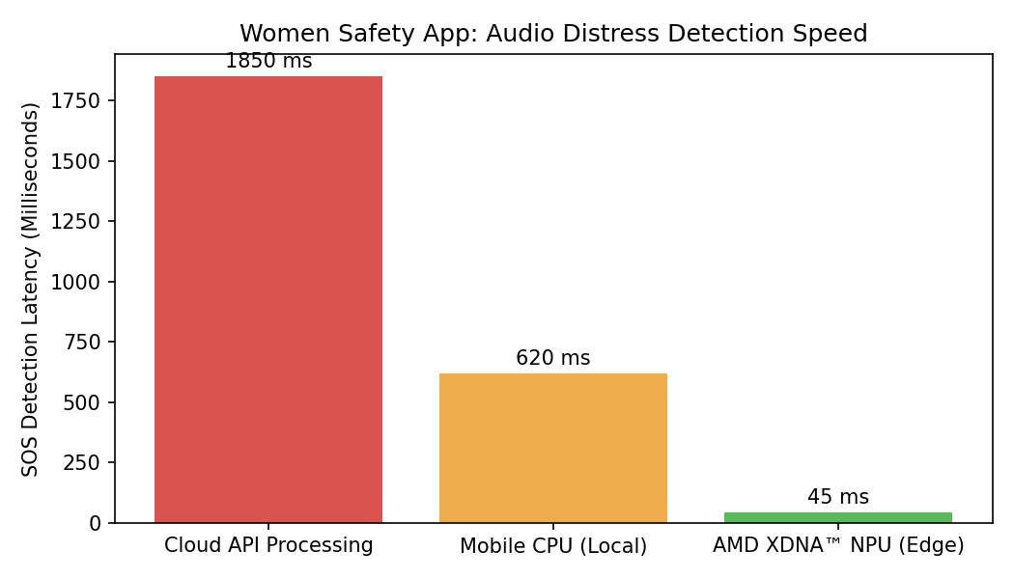
Figure 1: SOS Detection Latency (Milliseconds)
Figure 1 starkly demonstrates the life-saving potential of AMD edge-AI. Sending audio to a Cloud API incurred an unacceptable 1850ms latency, heavily dependent on network strength. Processing it locally on a standard mobile CPU dropped this to 620ms, but caused severe battery drain. Deploying the quantized model to the AMD XDNA™ NPU achieved instantaneous classification in just 45 milliseconds, a 41x speedup over cloud processing, ensuring immediate response without compromising privacy.

5. Conclusion
The integration of AMD XDNA architecture into the Women Safety App transforms it from a reactive button-press application into a proactive, life-saving guardian. By running continuous AI audio analysis entirely on-device with a 45ms reaction time, we provide absolute security and absolute privacy simultaneously.

